Pizza Sales SQL Queries
A.KPIs
1,Total Revenue
select sum(total_price) as Total_Revenue
from pizza_sales;
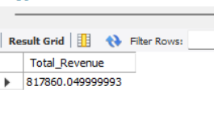
2, Average Order Value
select sum(total_price)/ count(distinct order_id) as Avg_order_value
from pizza_sales;
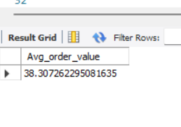
3, Total Pizza Sold
select sum(quantity) as Total_Pizza_Sold
from pizza_sales;
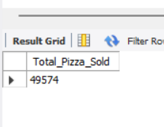
4, Total Orders
select count( distinct(order_id))as Total_Orders
from pizza_sales;
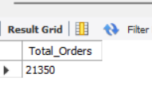
5.Average Pizzas per order
select round(sum(quantity) / count (distinct order_id), 2)as Avg_Pizza_per_Order
from pizza_sales;
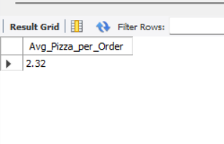

B. Chart Requirements
1.Daily Trends for total orders
select dayname(order_date) as order_date,count(distinct order_id) as total_orders
from pizza_sales
group by dayname(order_date),DAYOFWEEK(order_date)
ORDER BY DAYOFWEEK(order_date);
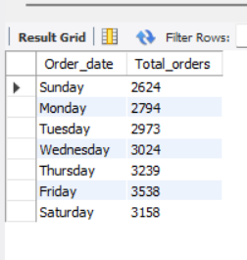
2. Monthly Trends for total orders
select monthname(order_date) as Month_name,count(distinct order_id) as Total_orders
from pizza_sales
group by monthname(order_date)
order by Total_orders desc;
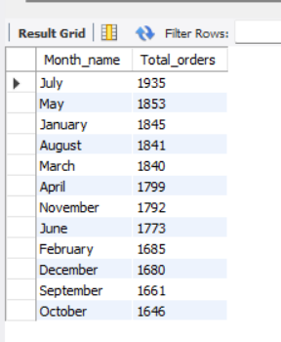
3.% of Sales by Pizza Category
select pizza_category, round (sum(total_price),2) as Total_Sales
,round(sum(total_price) * 100/
(select sum(total_price) from pizza_sales ),2) as Percentage_of_Sales
from pizza_sales
group by pizza_category ;
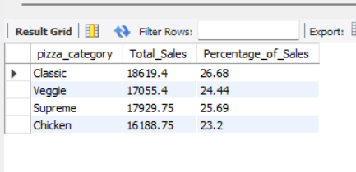
4.% os Sales by Pizza Size
SELECT
pizza_size,
ROUND(SUM(total_price), 2) AS Total_Sales,
ROUND(
SUM(total_price) * 100 / (
SELECT SUM(total_price)
FROM pizza_sales
WHERE MONTH(order_date) = 1 -- <--- Change Month Here (e.g., 1 for Jan)
), 2
) AS percentage_of_Sales_by_Size
FROM pizza_sales
WHERE MONTH(order_date) = 1 -- <--- Change Month Here (e.g., 1 for Jan)
GROUP BY pizza_size
ORDER BY percentage_of_Sales_by_Size DESC;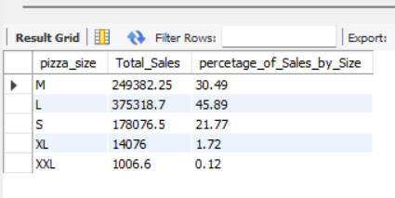

6.Top 5 by Revenue
SELECT
pizza_name,
ROUND(SUM(total_price), 2) AS Total_Revenue
FROM pizza_sales
GROUP BY pizza_name
ORDER BY Total_Revenue DESC
LIMIT 5;

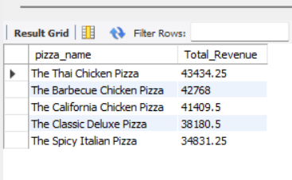

7.Bottom 5 pizzas by Revenue
SELECT
pizza_name,
ROUND(SUM(total_price), 2) AS Total_Revenue
FROM pizza_sales
GROUP BY pizza_name
ORDER BY Total_Revenue asc
LIMIT 5;
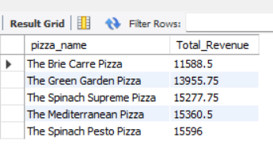
8.Top 5 pizzas by Quantity
SELECT
pizza_name,
SUM(quantity) AS Total_Quantity
FROM pizza_sales
GROUP BY pizza_name
ORDER BY Total_Quantity desc
LIMIT 5;
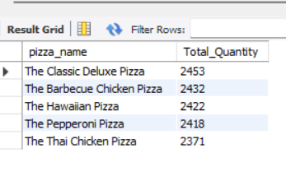
9.Bottom 5 pizzas by Quantity
SELECT
pizza_name,
SUM(quantity) AS Total_Quantity
FROM pizza_sales
GROUP BY pizza_name
ORDER BY Total_Quantity asc
LIMIT 5;
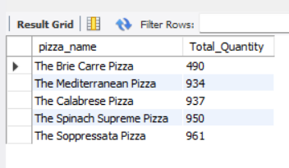
10.Top 5 pizzas by Orders
SELECT
pizza_name,
count(distinct order_id) AS Total_Orders
FROM pizza_sales
GROUP BY pizza_name
ORDER BY Total_Orders desc limit 5;
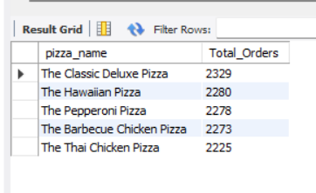
11.Bottom 5 pizzas by Orders
SELECT
pizza_name,
count(distinct order_id) AS Total_Orders
FROM pizza_sales
GROUP BY pizza_name
ORDER BY Total_Orders asc
limit 5
;
